**What is Amazon?**

* It is an American multinational technology company.
* It focuses on e-commerce, cloud computing, online advertising, digital streaming, and artificial intelligence.
* It is the world's largest online retailer with over 2.9 trillion USD in annual sales.
* It has over 314.8 million active customers.
* It was founded by Jeff Bezos in 1994.
* It is headquartered in Seattle, Washington.
* It has over 1.6 million employees worldwide.
* It is one of the most valuable companies in the world.

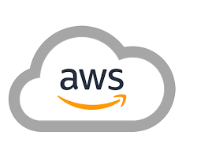

**What is AWS?**

* AWS is a collection of remote computing services (web services) that together make up a cloud computing platform, offered over the Internet by **Amazon.com.**
* The website: <http://aws.amazon.com/>
* **AWS is located in 25 geographical Regions, Each Region is wholly contained within a single country.**

**What is a service?**

A service is a specific utility offered by a cloud provider to help clients.

1. **Specific utility:** A service is a specific task or function that is performed by a cloud provider.
2. **Offered by a cloud provider:** Services are offered by cloud providers such as Amazon Web Services (AWS), Microsoft Azure, and Google Cloud Platform (GCP).
3. **Helps clients:** Services are designed to help clients achieve their goals, such as storing data, running applications, or analyzing data.
4. **Examples of services:** Some examples of cloud services include:
   * **Storage services:** S3 (Simple Storage Service)
   * **Compute services:** EC2 (Elastic Compute Cloud)
   * **Database services:** Amazon Aurora
   * **Networking services:** Amazon Route 53
   * **Management tools:** AWS CloudWatch
5. **Key characteristics of services:**
   * **Pay-as-you-go pricing:** Clients only pay for the resources they use.
   * **Scalability:** Services can be easily scaled up or down to meet changing needs.
   * **Reliability:** Services are highly reliable and have a high level of availability.
   * **Security:** Services provide a wide range of security features to help protect data and applications.

**What are the top three cloud platforms?**

The top three cloud platforms are AWS, Azure, and GCP.

* AWS is the most popular cloud platform, with a market share of over 33%.
* Azure is the second most popular cloud platform, with a market share of over 21%.
* GCP is the third most popular cloud platform, with a market share of over 8%.

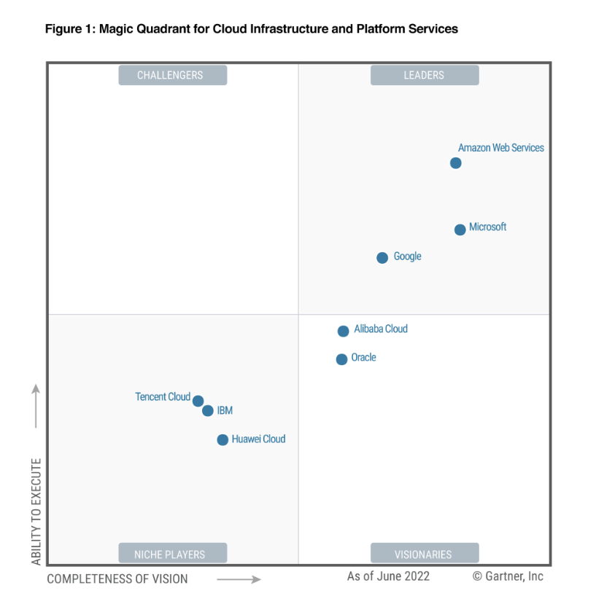

**What AWS offer?**

AWS offers availability, Scalability, pay-as-you-go.

* Availability means there is no downtime. Only pre-requisite is to have an internet connection. AWS promises - 11 9's of availability 99.999999999
* Scalability is ability to grow in size. Instant elasticity (scaling up and down). Eliminate guessing of your infrastructure capacity needs.
* Pay-as-you-go is low ongoing cost, pay-as-you-go pricing with no upfront expenses or long-term commitments.

**What are the services provided by AWS?**

AWS provides a wide range of services, including:

* **Compute:** EC2, Lambda, Elastic Beanstalk
* **Storage:** S3, Elastic Block Store, Amazon Glacier, AWS Snowball
* **Database:** Amazon Aurora, Amazon RDS, Amazon DynamoDB, Amazon RedShift
* **Migration:** AWS Database Migration Service, AWS Snowball
* **Networking and Content Delivery:** Amazon Route 53, AWS CloudFront
* **Management Tools:** AWS CloudWatch, AWS CloudFormation, AWS CloudTrail
* **Security & Identity Compliance:** AWS IAM, AWS KMS, AWS Shield
* **Messaging:** Amazon SQS, Amazon SNS, Amazon SES, Amazon Pinpoint

**What are the advantages of AWS?**

* **Easy to use:** AWS has a user-friendly interface and a wide range of documentation and support resources.
* **Flexible:** AWS offers a wide range of services that can be used to build a variety of applications.
* **Cost-effective:** AWS offers a pay-as-you-go pricing model, so you only pay for the resources that you use.
* **Reliable:** AWS has a high level of availability and performance.
* **Scalable:** AWS can be easily scaled up or down to meet your changing needs.
* **Secure:** AWS has a wide range of security features that can help protect your data and applications.

**What about certification?**

